**State Machines in C**

a state machine is a design pattern used to manage and transition between different states of a system based on inputs or events. This pattern is particularly useful for implementing complex logic where the system needs to respond differently depending on its current state.

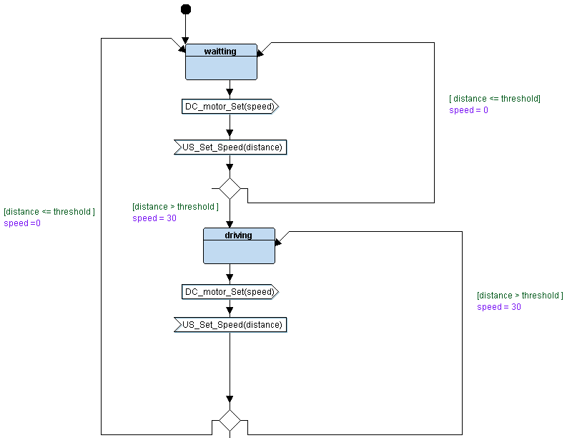

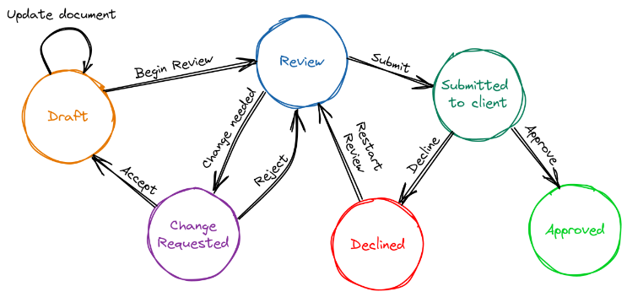

**Key Concepts**

1. **States**: Represent the different conditions or modes the system can be in. Each state may have specific behaviors or actions associated with it.
2. **Transitions**: Define how the system moves from one state to another based on certain conditions or inputs.
3. **Events**: Trigger transitions between states. Events are typically inputs or conditions that cause the system to change its state.

**Flowchart symbols**

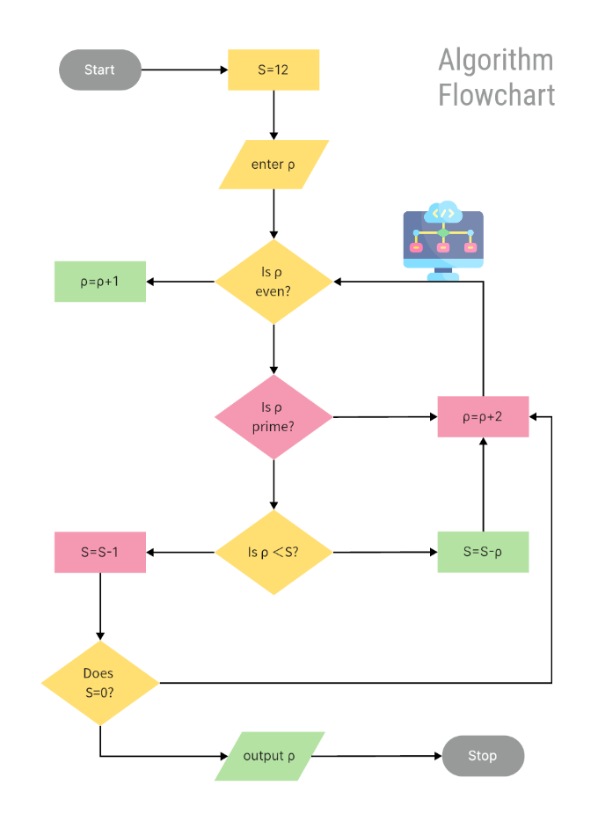A flowchart is a diagrammatic representation used to visualize the sequence of steps and decisions in a process or system. It helps in understanding, designing, and analyzing processes by breaking them down into individual components and illustrating the flow of control between them.

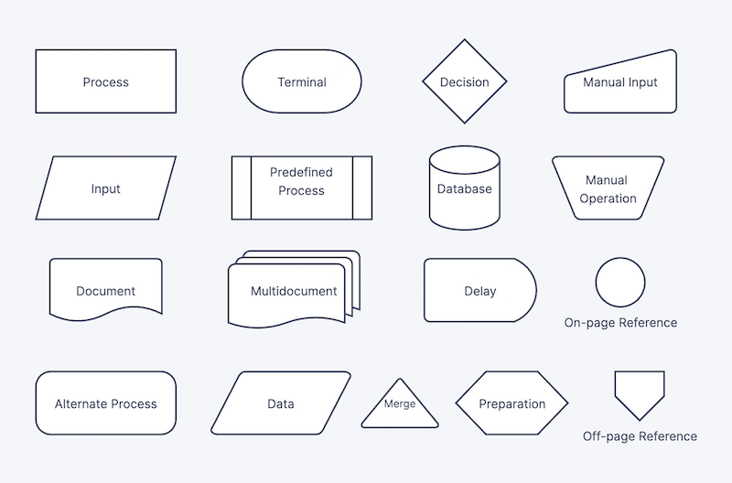

### Key Features of Flowcharts

1. **Visual Representation**: Flowcharts use symbols and shapes to represent different types of actions, decisions, and processes, making complex workflows easier to understand.
2. **Step-by-Step Process**: They illustrate each step in a process, from the start to the end, showing how inputs are transformed into outputs.
3. **Decision Points**: Flowcharts highlight decision points where different paths can be taken based on certain conditions.
4. **Flow Direction**: Arrows or lines indicate the direction of flow between different steps or actions.

**State Machine vs Flowchart**

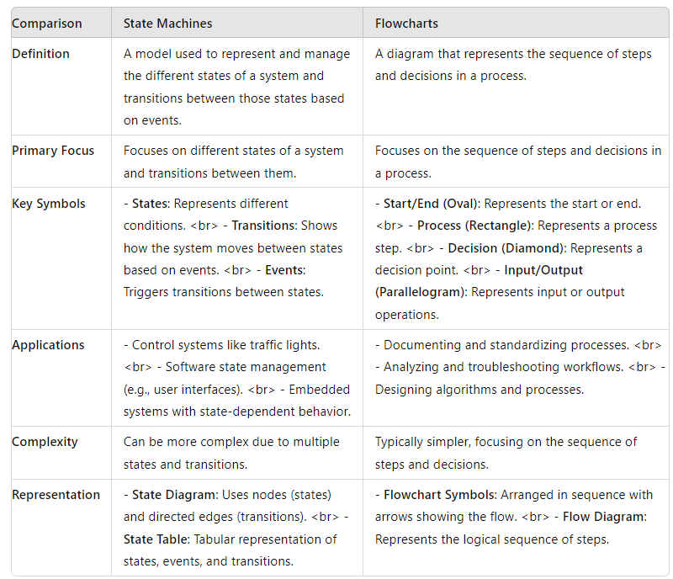

**types of state machines**

* **Finite State Machine (FSM)**: Basic state machine with a finite number of states.
* **Moore Machine**: Output depends only on the current state.
* **Mealy Machine**: Output depends on both the current state and input.
* **Hierarchical State Machine**: States are nested within other states.
* **Extended State Machine**: Includes additional variables affecting transitions.
* **Probabilistic State Machine**: Uses probabilities for state transitions.
* **Timed State Machine**: Transitions are based on time constraints.

**Implement Simple state machine in C**

**using multiple Modules**

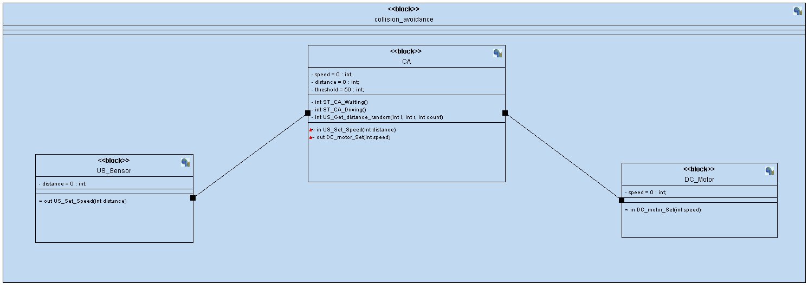

US_Sensor

/*

* CA.c

*

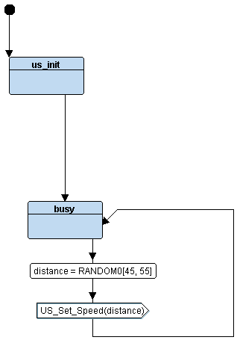 * Created on: Aug 4, 2024

* Author: Abdallah Ghazy

*/

**#include** "US.h"

**int** US_distance = 0;

**int** **US_Get_distance_random**(**int** l, **int** r, **int** count) {

**return** (**rand**() % (r - l + 1)) + l;

}

**void** (*US_state)();

**US_init**(){

**printf**("\nUS_init......");

}

STATE_define(US_busy) {

US_state_id = *US_busy*;

US_distance = **US_Get_distance_random**(45, 55, 1);

**printf**("\n CA_Waiting State: distance = %d Speed = %d \n", US_distance);

**US_set_distance**(US_distance);

US_state = STATE(US_busy);

}

Collision avoiding

/*

* CA.c

*

* Created on: Aug 4, 2024

* Author: Abdallah Ghazy

*/

**#include** "CA.h"

**int** CA_speed = 0;

**int** CA_distance = 0;

**int** CA_threshold = 50;

**void** (*CA_state)();

**void** **US_set_distance**(**int** d){

CA_distance = d;

CA_state = (CA_distance <= CA_threshold) ? STATE(CA_waiting) : STATE(CA_driving);

**printf**("US-------------- Distance = %d -------------------------- \n",CA_distance);

}

STATE_define(CA_waiting) {

CA_state_id = *CA_waiting*;

**printf**("\n CA_Waiting State: distance = %d Speed = %d \n", CA_distance, CA_speed);

CA_speed = 0;

**DC_motor**(CA_speed);

}

STATE_define(CA_driving) {

CA_state_id = *CA_driving*;

CA_speed = 30;

**printf**("\n CA_Driving State: distance = %d Speed = %d \n", CA_distance, CA_speed);

**DC_motor**(CA_speed);

}

**DC_Motor**

/*

* CA.c

*

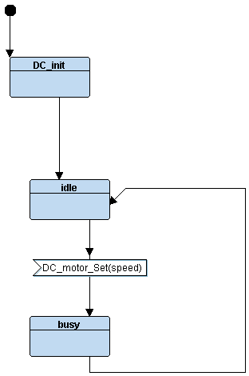 * Created on: Aug 4, 2024

* Author: Abdallah Ghazy

*/

**#include** "DC.h"

**#include** "state.h"

**int** DC_speed = 0;

**void** (*DC_state)();

**void** **DC_init**() {

**printf**("DC_init.............");

}

**void** **DC_motor**(**int** s) {

DC_speed = s;

DC_state = STATE(DC_busy);

**printf**("US-------------- DC_speed = %d -------------------------- \n",

DC_speed);

}

STATE_define(DC_idle) {

DC_state_id = *DC_idle*;

**printf**("\n DC_idle State: Speed = %d \n", DC_speed);

}

STATE_define(DC_busy) {

DC_state_id = *DC_busy*;

**printf**("US-------------- DC_speed = %d -------------------------- \n",

DC_speed);

}

